# Supplementary Material

NH3-NO interaction under low-temperatures: an experimental and modeling study

Maria Virginia Mannaa,b,*, Pino Sabiaa, Krishna P. Shresthac, Lars Seideld, Raffaele Raguccia, Fabian Maussc, Mara de Joannona

a *Institute of Science and Technology for Sustainable Energy and Mobility - Consiglio Nazionale delle Ricerche, Napoli, Italy.*

b *Department of Chemical, Materials and Production Engineering - University of Napoli Federico II, Napoli, Italy.*

*c Thermodynamics and Thermal Process Engineering - Brandenburg University of Technology, Cottbus, Germany.*

*d LOGE Deutschland GmbH, Cottbus, Germany.*

*Proceedings of the Combustion Institute 39 (2022)*

# Section A: Numerical predictions with other kinetic models

Recent detailed kinetic mechanisms from literature [1–3] were selected and tested against the experimental JSFR data in order to compare their performance with the current model.

Glarborg et al. mechanism [1] (Glarborg2018) was developed for the prediction of NOx formation and reduction in oxidation processes. Specifically, NH3 sub-mechanism was developed starting from the work by Klippenstein et al. [4] and validated against NH3 ignition delay time by Mathieu and Petersen [5] and low-pressure (35 Torr) flame experiments by Bian et al. [6].

The core H2/O2 mechanism in the kinetic model by Stagni et al. [2] (Stagni2020) is based on the work of Metcalfe et al. [7], while the NH3 sub-mechanism was developed from the work by Song et al. [8]. It was validated against jet-stirred reactor and a flow reactor data, under lean conditions (0.01 ≤ Φ ≤ 0.375), for temperatures in the range 500 K ≤ T ≤ 2000 K. The mechanism was also tested against the ignition delay time of Mathieu and Petersen [5].

The kinetic mechanism by Zhang et al. [3] (Zhang2021) was based on the study by Mei et al. [9] and it was validated against NH3/H2 mixtures oxidation in a JSFR, under atmospheric pressure, for a temperature range over 800-1280 K. Different mixture equivalence ratios (0.25 and 1.0) and hydrogen contents (from zero to 70%) were explored.

The comparison between experimental and numerical results is reported in Fig.S1 mechanism by mechanism.

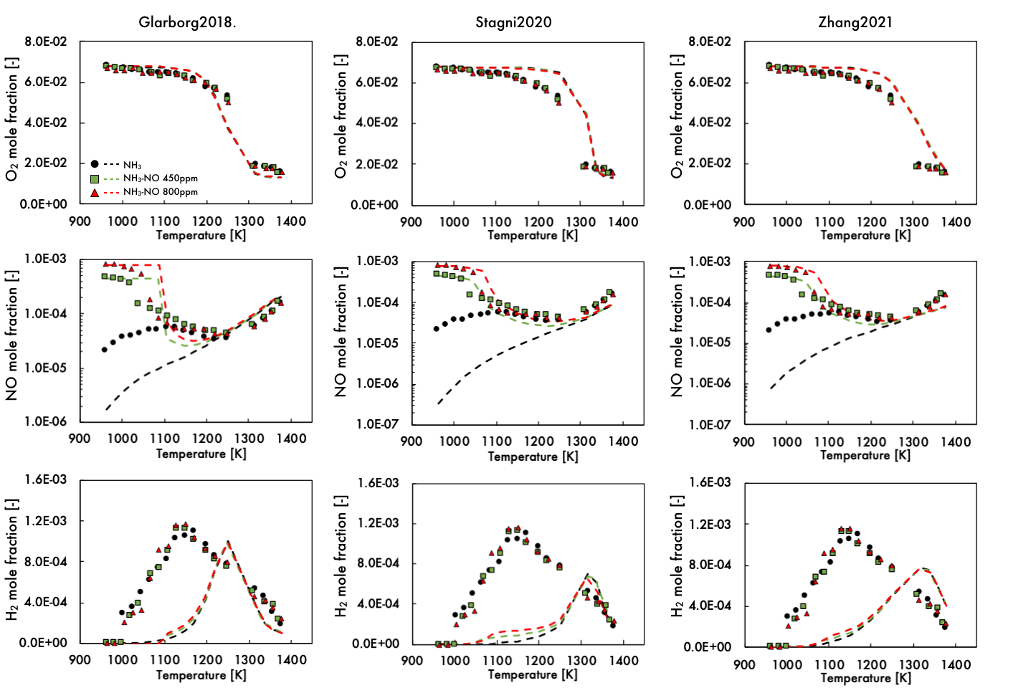

*Figure S1. Comparison between experimental data from the present work and numerical predictions with different kinetic models (Glarborg2018, Stagni2020, Zhang2021). Symbols: experimental data. Dashed lines: numerical results.*

Zhang2021 and Stagni2020 envisage similar predictions for both NH3 and NH3-NO oxidation. In particular, they are not able to capture the NO trend for the oxidation of pure NH3 for the low temperatures, while the agreement between experimental and numerical profile improves for higher temperatures. In case of NH3-NO mixtures, the NO profile is better described, even though the onset of NO reduction is slightly shifted at higher temperatures compared to experiments.

From the O2 profiles, it can be seen that both the models predict slower reactivity compared to the experimental data. Also the H2 trend is not reproduced and its formation is underestimated for temperatures lower than 1300K. Similarly to the other mechanisms, Glarborg2018 scheme cannot predict the NO non-monotonic trend for temperatures lower than 1250K, while it provides better predictions for higher temperatures and for NO profiles in case of NH3-NO mixtures. The model well reproduces the O2 profiles. To some extent, the H2 trend is predicted by Glarborg2018 model, even though its formation is shifted to higher temperature compared to the experimental data.

# Section B: Performance of the current mechanism against other literature data

**Jet Stirred Flow Reactor**

The optimized kinetic mechanisms was tested against other experimental data from different devices and operative conditions. In particular, the performance of the mechanism were verified for experimental data on NH3-NO interaction from Dagaut [10] and Alzueta et al. [11] and for NH3 laminar flame speed [12] and ignition delay time [13] at different equivalence ratios.

Fig. S1 shows the results for NH3-NO oxidation in JSFR for various equivalence ratios (0.1, 2) and initial concentrations of NO equal to1000 ppm, at atmospheric pressure [10]. The experiments are performed as a function of the temperature in the range 1100-1450K, at fixed residence time (0.1s). The prediction of Shrestha2021 mechanism is reported as dashed line on the same plot. The present model well reproduce the NH3, H2O and NO profiles at fuel lean condition, for different initial concentration of NO. The mixture reactivity at ultra-fuel-rich conditions is not reproduced by the mechanism, that predicts a lower reactivity compared to the experimental data.

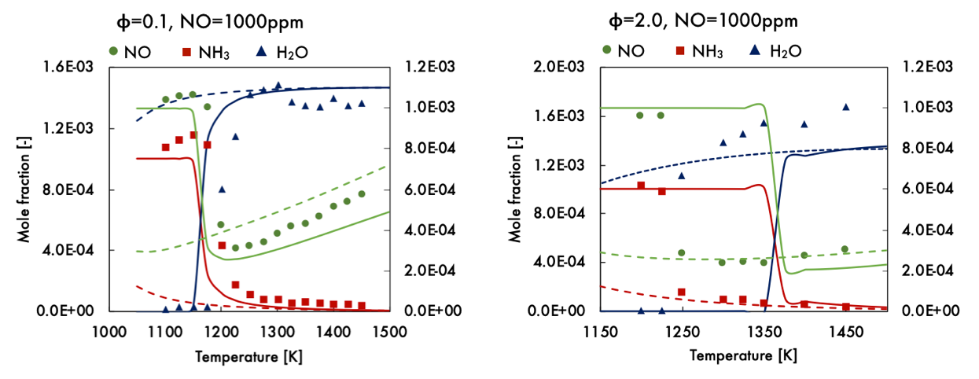

*Figure S2. Speciation of NH3/NO oxidation in a JSFR at atmospheric pressure for different air excess ratio. Symbols: experimental data from Dagaut [10]. Solid lines: prediction with the present mechanism. Dashed lines: prediction with Shrestha2021 mechanism.*

**Tubular flow reactor**

The NH3-NO interaction was also experimentally investigated recently by Alzueta et al. [11] in laboratory tubular flow reactor at atmospheric pressure, for temperatures in the 700-1500K range, various air excess ratio () and NH3/NO ratio in the range 0.7-3.5. The NH3 and NO profiles in comparison to model predictions are reported in Fig. S2. The prediction of Shrestha2021 mechanism is reported as dashed line on the same plot.

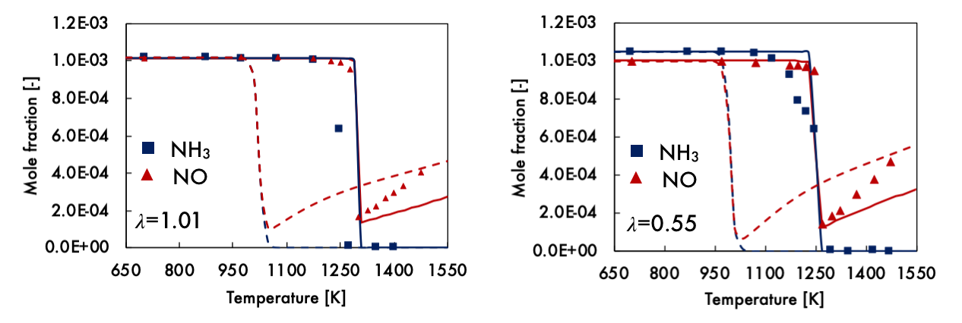

Figure S3. Speciation of NH3/NO oxidation in a flow reactor at atmospheric pressure for different air excess ratio. Symbols: experimental data from Alzueta et al. [11]. Solid lines: prediction with the present mechanism. Dashed lines: prediction with Shrestha2021 mechanism

The present mechanism well reproduce NH3 and NO profiles at =1.65, 1.01. For fuel-rich condition (=0.55), the model underestimates the system reactivity, as it predicts reactants conversion for T>1350K, while the experiments show NH3 and NO decrease for T>1250K.

**Laminar flame speed and ignition delay time**

Fig. S3 reports the predicted NH3/air laminar burning velocities in comparison to experimental data collected by Shrestha et al. [12]. The prediction of Shrestha2021 mechanism is reported as dashed line on the same plot. The measured burning velocities exhibit a good agreement for fuel-lean and stoichiometric conditions, while discrepancies can be noticed for the rich conditions.

The model is able to predict the experimental data from fuel-lean to stoichiometric conditions, showing the best agreement with data by Pfahl2000. For fuel-rich conditions (<1.4), the mechanism prediction is in good agreement with the experiments by Ronney1988, but it predicts higher flame speed for >1.4.

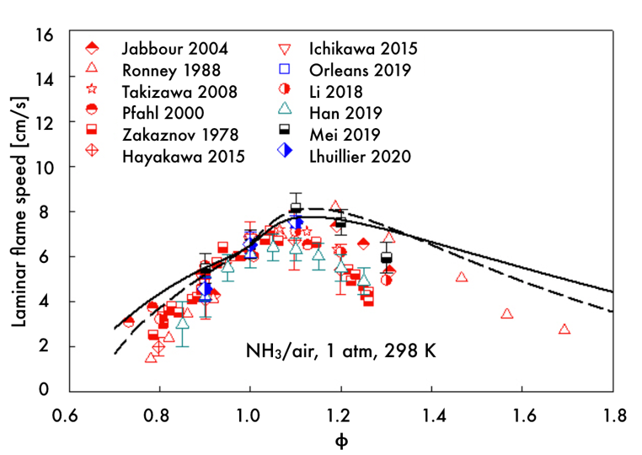

Figure S4. Laminar flame speed for NH3/air mixtures at 298K and 1atm. Symbols: experiments adapted from by Shrestha et al. [12]. Solid lines: prediction with the present mechanism. Dashed lines: prediction with Shrestha2021 mechanism.

The mechanism prediction for NH3/O2 ignition delay time from shock tube experiments are reported in Fig. S4. The experiments were reported by Mathieu and Petersen [13], for mixtures diluted in Ar at 98% and 99%, for various pressures (1.4, 11, 30 atm) and equivalence ratios (0.5, 1.0, 2.0).

The present model well reproduce the ignition delay time for fuel-lean and stoichiometric conditions, with small discrepancies for the data at 30 atm diluted at 98% in Ar. For the fuel-rich mixture, the mechanism is able to predict the experimental data for high pressure conditions, whereas it shows lower reactivity compared to the experiments at atmospheric pressure.

# 

Figure S5. Ignition delay time data from shock tube experiments for NH3/O2/Ar mixtures, at various pressures (1.4, 11, 30 atm) and equivalence ratios (0.5, 1.0, 2.0). Solid lines: prediction with the present mechanism. Dashed lines: prediction with Shrestha2021 mechanism.

# Section C: Influence of the declaration of NH3 third-body collisional efficiency

A collisional efficiency for NH3 was included in all the reactions of H2 and NH3 sub-mechanism which involved third body (+M). In order to demonstrate the influence of such parameter on these reactions, Reaction Rates (RRs) analysis were performed with the updated mechanism and the same one without declaring the collisional efficiency () for NH3. The comparison among the most influenced RRs is reported in the Figure S6 (solid line for =12, dashed line for =1).

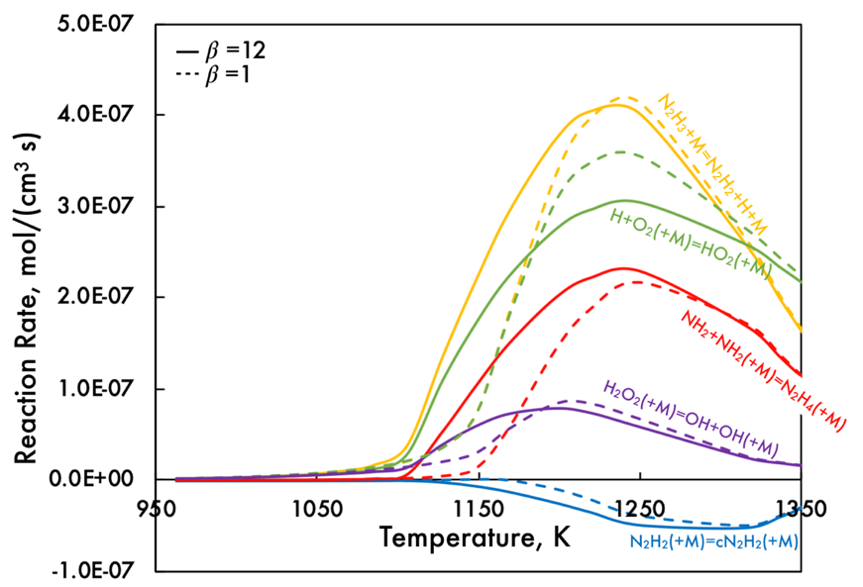

*Figure S6. Comparison between RRs according to the updated mechanism and the same one without the declaration of collisional efficiency for NH3.*

Reaction Rates (RRs) analysis revealed that adding NH3 collision efficiency affected the following reactions the most: H+O2(+M)=HO2(+M), H2O2(+M)=OH+OH(+M), N2H3+M=N2H2+H+M, NH2+NH2(+M)=N2H4(+M), N2H2(+M)=cN2H2(+M). In particular, these reactions become active at lower temperatures (RRs shifted of 50K). As a consequence, the relative concentration of radicals changes, as showed in Fig. S7.

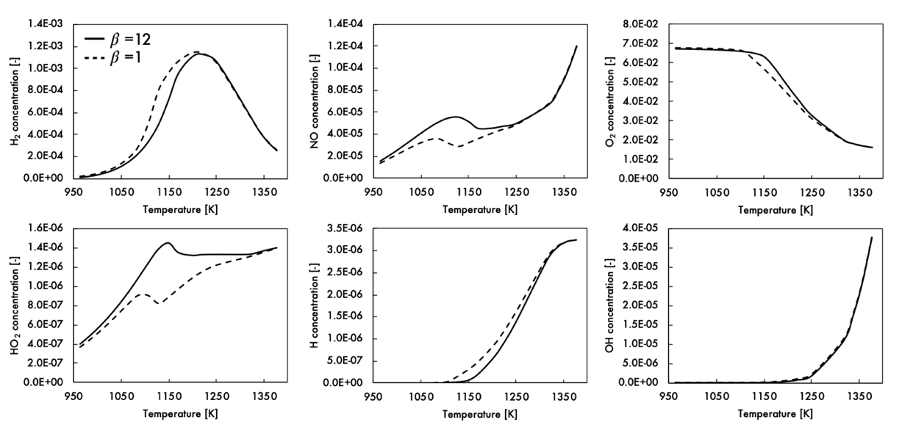

*Figure S7. Comparison between radicals and species profiles according to the updated mechanism and the same one without the declaration of collisional efficiency for NH3.*

In particular, for =12 the HO2 concentration increases while the H one decreases compared with the case =1. The increased concentration of HO2 radicals strongly influences the main stable species trends. Indeed, the overall reactivity of the mixture decreases, as showed by the O2 profile, while the NO peak is higher.

# Section D: Detailed description of the experimental system

Experimental data were collected using a fused-silica Jet Stirred Flow Reactor (volume 113 cm3). The gaseous mixture is fed to the reactor by two quartz tube, one for the oxidant and diluent (primary flow) and one for the fuel and diluent (secondary flow). The primary and secondary flows are mixed in a premixing chamber before the injection in the reactor, through four nozzles with a ID of 1mm located at the center of the reactor. The reactor and the gas feeding tubes are located between two semi-cylindrical electrically heated ceramic fiber ovens that allow to preheat the mixture and control the ambient temperature to reduce the heat loss. A recirculating air system allows to minimize the temperature gradients within the ovens.

The residence time of the reactant mixture in the premixing chamber is minimized to prevent any reactions before the injection in the reactor volume.

Gases are fed to the reactor by mass flow controllers provided (BronkHorst High Tech), while for water supply, the system is equipped with an evaporator system (CEM BronkHorst Hith Tech) and a liquid mass flow controller.

The temperature inside the reactor is measured by means of two thermocouples. In order to test if the thermocouples can promote catalytic effects, the same experimental tests were repeated with and without them, obtaining the same products species concentrations.

Any possible heterogeneous interaction of the reactant mixture with the quartz surface is prevented by surface passivation with water vapor. Nevertheless, previous studies highlighted that the occurrence of ammonia surface reaction is negligible for the considered operative conditions.

Due to the relatively low dilution level (mixtures are diluted in N2 at 86%), the heat release of the oxidation process is not negligible, indeed a temperature increment of about 80K is measured for full reactant conversion. Therefore, to take into account the temperature increment, the simulations were performed under isothermal conditions, considering as reference temperature for calculations (Tin) the real temperature (Tr) measured in the reactor at steady state conditions (Tr=Tin+T).

# Section E: Complete list of changed reactions

List of changed reactions with respect to Shrestha2021 mechanism. Reaction rates are given in the Arrhenius expression as k=A Tn exp[-Ea/RT]. Units are cal, mol, cm, s, K.

|  |  |  |  |  |  |
| --- | --- | --- | --- | --- | --- |
| **No.** | **Reaction** | **A** | **n** | **Ea** | **Comments** |
|  |  |  |  |  |  |
|  | **NH3 sub-mechanism** |  |  |  |  |
| R1 | NH2+H(+M)=NH3(+M) | 1.60E+14 | 0 | 0.00E+00 |  |
|  | Low-pressure limit | 3.60E+22 | -1.76 | 0.000E+00 |  |
|  | Troe parameters | 0.5 | 1.00E-30 | 1.00E+30 |  |
| R2 | NH3+H=H2+NH2 | 6.67E+06 | 2.13195 | 1.09E+04 |  |
| R3 | NH3+O=NH2+OH | 4.43E+02 | 3.18 | 6.74E+03 |  |
| R4 | NH3+OH=NH2+H2O | 4.30E+03 | 2.83021 | -4.31E+02 |  |
| R5 | NH3+HO2=NH2+H2O2 | 1.17E+00 | 3.839 | 1.73E+04 |  |
| R6 | NH3+O2=NH2+HO2 | 7.00E+09 | 1.285 | 5.52E+04 |  |
| R7 | NH3+NH2=N2H3+H2 | 1.90E+11 | 0.5 | 2.16E+04 |  |
|  |  |  |  |  |  |
|  | **NH2 sub-mechanism** |  |  |  |  |
| R8 | NH2+O=HNO+H | 3.30E+14 | -0.5 | 0.00E+00 |  |
| R9 | NH2+O=NO+H2 | 5.00E+12 | 0 | 0.00E+00 | removed |
| R10 | NH2+OH=NH+H2O | 6.04E+04 | 2.52 | -6.16E+02 |  |
| R11 | NH2+HO2=H2NO+OH | 6.25E+17 | -1.28 | 1.17E+03 |  |
| R12 | NH2+HO2=HNO+H2O | 1.60E+07 | 0.55 | 5.25E+02 |  |
|  | DUPLICATE |  |  |  |  |
| R12 | NH2+HO2=HNO+H2O | 5.70E+15 | -1.12 | 7.07E+02 |  |
|  | DUPLICATE |  |  |  |  |
| R13 | NH2+HO2=HON+H2O | 2.10E+07 | 0.64 | 8.11E+02 |  |
| R14 | NH2+O2=H2NO+O | 2.60E+11 | 0.4872 | 2.91E+04 |  |
| R15 | NH2+O2=HNO+OH | 2.90E-02 | 3.764 | 1.82E+04 |  |
| R16 | NH2+NH2=NH3+NH | 1.35E+01 | 3.53 | 5.53E+02 |  |
| R17 | NH2+NH=NH3+N | 1.20E+04 | 2.46 | 1.07E+02 |  |
| R18 | NH2+NO=N2+H2O | 2.60E+19 | -2.369 | 8.70E+02 |  |
| R19 | NH2+NO=NNH+OH | 4.30E+10 | 0.294 | -8.66E+02 |  |
| R20 | NH2+NO2=N2O+H2O | 2.20E+11 | 0.11 | -1.19E+03 |  |
| R21 | NH2+NO2=H2NO+NO | 2.15E+12 | 0.11 | -1.19E+03 |  |
| R22 | NH2+HNO=NH3+NO | 1.62E+03 | 2.95 | -3.47E+03 |  |
| R23 | NH2+HONO=NH3+NO2 | 7.11E+01 | 3 | -4.94E+03 | removed |
|  |  |  |  |  |  |
|  | **NH sub-mechanism** |  |  |  |  |
| R24 | N+NO=N2+O | 9.40E+12 | 0.14 | 0.00E+00 |  |
| R25 | NH+OH=HNO+H | 2.00E+13 | 0 | 0.00E+00 |  |
| R26 | NH+OH=NO+H2 | 1.20E+13 | 0 | 0.00E+00 |  |
| R27 | NH+OH=N+H2O | 4.00E+09 | 1.2 | 5.98E+00 |  |
| R28 | NH+O2=HNO+O | 4.05E+11 | 0.09 | 1.07E+04 |  |
| R29 | NH+O2=NO+OH | 2.01E+15 | -1.38 | 5.67E+03 |  |
| R30 | NH+NH=>N2+H+H | 5.63E+13 | -0.036 | -1.61E+02 |  |
| R31 | NH+NH=>N2+H2 | 6.26E+12 | -0.036 | -1.61E+02 |  |
| R32 | NH+NO=N2O+H | 2.70E+15 | -0.78 | 2.00E+01 |  |
| R33 | NH+NO=N2+OH | 6.80E+14 | -0.78 | 2.00E+01 |  |
|  |  |  |  |  |  |
|  | **NNH sub-mechanism** |  |  |  |  |
| R34 | NNH=N2+H | 1.00E+09 | 0 | 0.00E+00 |  |
| R35 | NNH+O=N2O+H | 1.90E+14 | -0.274 | -2.20E+01 |  |
| R36 | NNH+O=NH+NO | 5.20E+11 | 0.381 | -4.09E+02 |  |
| R37 | NNH+O2=N2+HO2 | 5.60E+14 | -0.385 | -1.30E+01 |  |
| R38 | NNH+HO2=N2+H2O2 | 1.40E+05 | 2.69 | -1.60E+03 |  |
| R39 | NNH+NO2=N2+HONO | 1.74E+01 | 2.84 | 1.67E+03 |  |
|  |  |  |  |  |  |
|  | **N2H2 sub-mechanism** |  |  |  |  |
| R40 | N2H2(+M)=cN2H2(+M) | 4.90E+09 | 1.18 | 4.77E+04 |  |
|  | Low-pressure limit | 3.00E+28 | -3.56 | 5.61E+04 |  |
|  | Troe parameters | 0.35 | 650 | 1.06E+04 |  |
|  | DUPLICATE |  |  |  |  |
| R41 | N2H2(+M)=cN2H2(+M) | 1.50E+14 | 0 | 5.50E+04 |  |
|  | Low-pressure limit | 2.30E+29 | -4 | 6.01E+04 |  |
|  | Troe parameters | 0.35 | 650 | 1.06E+04 |  |
|  | DUPLICATE |  |  |  |  |
| R42 | cN2H2+H=N2H2+H | 7.80E+08 | 1.58 | 2.18E+03 |  |
| R43 | N2H2+M=NNH+H+M | 1.90E+27 | -3.05 | 6.61E+04 | removed |
| R44 | N2H2(+M)=NNH+H(+M) | 6.30E+16 | 0 | 6.40E+04 |  |
|  | Low-pressure limit | 8.70E+39 | -6.91 | 7.04E+04 |  |
|  | Troe parameters | 0.44 | 520 | 6.15E+03 |  |
| R45 | cN2H2(+M)=NNH+H(+M) | 2.20E+16 | 0 | 5.87E+04 |  |
|  | Low-pressure limit | 3.70E+35 | -5.44 | 6.39E+04 |  |
|  | Troe parameters | 0.44 | 520 | 6.15E+03 |  |
| R46 | N2H2+H=NNH+H2 | 4.50E+07 | 1.8 | 9.00E+02 |  |
| R47 | cN2H2+H=NNH+H2 | 1.40E+08 | 1.72 | 4.70E+02 |  |
| R48 | N2H2+O=NNH+OH | 1.11E+08 | 1.62 | 8.05E+02 |  |
| R49 | N2H2+NH2=NNH+NH3 | 2.70E+05 | 2.226 | -1.03E+03 |  |
| R50 | NH2+NH=N2H2+H | 1.65E+14 | -0.272 | -7.80E+01 |  |
| R51 | NH2+NH=cN2H2+H | 5.00E+13 | -0.272 | -7.80E+01 |  |
| R52 | NH2+NH2=N2H2+H2 | 3.40E+08 | 1.02 | 5.93E+03 |  |
| R53 | N2H2+HO2=NNH+H2O2 | 5.00E+12 | 0 | 1.99E+03 |  |
| R54 | N2H2+M=NH+NH+M | 3.16E+16 | 0 | 9.94E+04 | removed |
| R55 | NH+NH=N2H2 | 7.83E+13 | -0.036 | -1.61E+02 |  |
| R56 | N2H2+NO2=NNH+HONO | 1.12E-03 | 4.47 | 7.19E+03 |  |
|  |  |  |  |  |  |
|  | **N2H3 sub-mechanism** |  |  |  |  |
| R57 | N2H3(+M)=N2H2+H(+M) | 1.30E+11 | 0.819 | 4.81E+04 |  |
|  | Low-pressure limit | 3.80E+40 | -6.88 | 5.45E+04 |  |
|  | Troe parameters | 80000 | 28 | 7.30E+03 |  |
| R58 | N2H3+H=NH2+NH2 | 1.00E+14 | 0 | 1.50E+03 |  |
| R59 | N2H3+H=N2H2+H2 | 4.60E+01 | 3.53 | 3.75E+03 |  |
| R60 | N2H3+H=cN2H2+H2 | 2.70E+02 | 3.18 | 6.62E+03 |  |
| R61 | N2H3+NH2=N2H2+NH3 | 6.10E-01 | 3.574 | 1.19E+03 |  |
| R62 | N2H3+NH2=H2NN+NH3 | 1.10E+01 | 3.08 | 2.11E+02 |  |
| R63 | N2H3+H=H2NN+H2 | 3.10E+06 | 2.11 | 2.88E+02 |  |
| R64 | N2H3+M=NH2+NH+M | 5.00E+16 | 0 | 6.00E+04 |  |
|  |  |  |  |  |  |
|  | **N2H4 sub-mechanism** |  |  |  |  |
| R65 | N2H4=H2NN+H2 | 1.40E+14 | 0 | 7.49E+04 |  |
| R66 | N2H4+H=NH3+NH2 | 4.46E+09 | 0 | 3.10E+03 |  |
| R67 | N2H4+OH=N2H3+H2O | 2.35E+13 | 0 | 0.00E+00 |  |
| R68 | N2H4+NH2=N2H3+NH3 | 7.60E-01 | 4 | 4.05E+03 |  |
| R69 | N2H4+NO=N2H3+HNO | 6.00E+01 | 3.16 | 3.08E+04 |  |
| R70 | N2H4+NO2=N2H3+HONO | 8.20E+01 | 3.13 | 8.86E+03 |  |
| R71 | N2H4+NO2=N2H3+HNO2 | 2.40E-02 | 4.14 | 7.95E+03 |  |
|  |  |  |  |  |  |
|  | **H2NO sub-mechanism** |  |  |  |  |
| R71 | H2NO+M=HNO+H+M | 2.80E+24 | -2.83 | 6.49E+04 |  |
| R72 | H2NO+H=HNO+H2 | 1.00E+07 | 2 | 2.00E+03 |  |
| R73 | H2NO+H=NH2+OH | 8.50E+13 | 0 | 0.00E+00 |  |
| R74 | H2NO+OH=HNO+H2O | 3.00E+13 | 0 | 0.00E+00 |  |
| R75 | H2NO+NO2=HONO+HNO | 9.00E+11 | 0 | 2.00E+03 |  |
| R76 | H2NO+NH2=HNO+NH3 | 3.60E+06 | 1.94 | -5.80E+02 |  |
|  |  |  |  |  |  |
|  | **HNO sub-mechanism** |  |  |  |  |
| R77 | NO+H(+M)=HNO(+M) | 1.52E+15 | -0.41 | 0.00E+00 | removed |
| R78 | HNO=H+NO | 1.83E+20 | -3.008 | 4.79E+04 |  |
|  | 0.1 atm | 2.01E+19 | -3.021 | 4.78E+04 |  |
|  | 1 atm | 1.83E+20 | -3.008 | 4.79E+04 |  |
|  | 10 atm | 1.28E+21 | -2.959 | 4.81E+04 |  |
|  | 100 atm | 5.64E+21 | -2.855 | 4.85E+04 |  |
|  | 1000 atm | 9.71E+21 | -2.642 | 4.89E+04 |  |
| R79 | HNO+H=NO+H2 | 6.60E+10 | 0.94 | 4.95E+02 |  |
| R80 | HNO+OH=NO+H2O | 6.30E+10 | 0.39 | 3.78E+03 |  |
|  | 0.01 atm | 5.82E+10 | 0.4 | 3.76E+03 |  |
|  | 0.1 atm | 5.85E+10 | 0.4 | 3.76E+03 |  |
|  | 0.316 atm | 5.92E+10 | 0.4 | 3.76E+03 |  |
|  | 1 atm | 6.30E+10 | 0.39 | 3.78E+03 |  |
|  | 3.16 atm | 9.53E+10 | 0.34 | 3.93E+03 |  |
|  | 10 atm | 2.60E+11 | 0.23 | 4.41E+03 |  |
|  | 31.6 atm | 3.83E+11 | 0.2 | 5.10E+03 |  |
|  | 100 atm | 4.18E+10 | 0.51 | 5.53E+03 |  |
| R81 | HNO+HO2=HNO2+OH | 2.00E+03 | 2.36 | 8.98E+03 |  |
| R82 | HNO+O2=NO+HO2 | 3.99E+05 | 2.3026 | 1.46E+04 |  |
|  |  |  |  |  |  |
|  | **NOx sub-mechanism** |  |  |  |  |
| R83 | NO+OH=HONO | 3.09E+23 | -4.17 | 1.62E+03 |  |
|  | 0.01 atm | 5.02E+21 | -4.24 | 8.99E+02 |  |
|  | 0.1 atm | 5.31E+22 | -4.24 | 1.18E+03 |  |
|  | 0.316 atm | 1.38E+23 | -4.22 | 1.38E+03 |  |
|  | 1 atm | 3.09E+23 | -4.17 | 1.62E+03 |  |
|  | 3.16 atm | 5.45E+23 | -4.09 | 1.91E+03 |  |
|  | 10 atm | 6.35E+23 | -3.97 | 2.22E+03 |  |
|  | 31.6 atm | 3.68E+23 | -3.75 | 2.50E+03 |  |
|  | 100 atm | 7.29E+22 | -3.41 | 2.66E+03 |  |
| R84 | NO2+O=NO+O2 | 2.59E+15 | -1.035 | 2.26E+02 |  |
|  | DUPLICATE |  |  |  |  |
| R85 | NO2+O=NO+O2 | 4.24E+16 | -0.861 | 5.09E+04 |  |
|  | DUPLICATE |  |  |  |  |
| R86 | N2O+H2=N2+H2O | 7.00E+12 | 0 | 3.25E+04 |  |
|  |  |  |  |  |  |
|  | **HONO sub-mechanism** |  |  |  |  |
| R87 | HNO+OH=HONO+H | 1.48E+03 | 2.72 | 4.55E+03 |  |
|  | 0.01 atm | 1.06E+03 | 2.76 | 4.44E+03 |  |
|  | 0.1 atm | 1.09E+03 | 2.75 | 4.45E+03 |  |
|  | 0.316 atm | 1.18E+03 | 2.74 | 4.48E+03 |  |
|  | 1 atm | 1.48E+03 | 2.72 | 4.55E+03 |  |
|  | 3.16 atm | 2.71E+03 | 2.64 | 4.77E+03 |  |
|  | 10 atm | 9.67E+03 | 2.49 | 5.25E+03 |  |
|  | 31.6 atm | 5.31E+04 | 2.29 | 6.06E+03 |  |
|  | 100 atm | 1.03E+05 | 2.24 | 6.95E+03 |  |
| R88 | HONO+H=NO2+H2 | 1.89E+03 | 2.83 | 1.42E+03 |  |
| R89 | HONO+H=NO+H2O | 4.30E+09 | 0.98 | 4.07E+03 |  |
|  | 0.01 atm | 3.91E+09 | 0.99 | 4.05E+03 |  |
|  | 0.1 atm | 3.93E+09 | 0.99 | 4.05E+03 |  |
|  | 0.316 atm | 3.97E+09 | 0.99 | 4.05E+03 |  |
|  | 1 atm | 4.30E+09 | 0.98 | 4.07E+03 |  |
|  | 3.16 atm | 7.04E+09 | 0.92 | 4.23E+03 |  |
|  | 10 atm | 2.60E+10 | 0.76 | 4.74E+03 |  |
|  | 31.6 atm | 7.91E+10 | 0.64 | 5.52E+03 |  |
|  | 100 atm | 2.79E+10 | 0.8 | 6.15E+03 |  |
| R90 | HONO+NH2=NH3+NO2 | 3.17E+02 | 2.83 | -3.57E+03 |  |

**References**

[1] P. Glarborg, J.A. Miller, B. Ruscic, S.J. Klippenstein, Modeling nitrogen chemistry in combustion, *Prog. Energy Combust. Sci.* 67 (2018) 31–68.

[2] A. Stagni, C. Cavallotti, S. Arunthanayothin, Y. Song, O. Herbinet, F. Battin-Leclerc, T. Faravelli, An experimental, theoretical and kinetic-modeling study of the gas-phase oxidation of ammonia, *React. Chem. Eng.* 5 (2020) 696–711.

[3] X. Zhang, S.P. Moosakutty, R.P. Rajan, M. Younes, S.M. Sarathy, Combustion chemistry of ammonia/hydrogen mixtures: Jet-stirred reactor measurements and comprehensive kinetic modeling, *Combust. Flame*. 234 (2021) 111653.

[4] S.J. Klippenstein, L.B. Harding, P. Glarborg, J.A. Miller, The role of NNH in NO formation and control, *Combust. Flame*. 158 (2011) 774–789.

[5] O. Mathieu, E.L. Petersen, Experimental and modeling study on the high-temperature oxidation of Ammonia and related NOx chemistry, *Combust. Flame*. 162 (2015) 554–570.

[6] J. Bian, J. Vandooren, P.J. Van Tiggelen, Experimental study of the formation of nitrous and nitric oxides in H2-O2-Ar flames seeded with NO and/or NH3, *Symp. Combust.* 23 (1991) 379–386.

[7] W.K. Metcalfe, S.M. Burke, S.S. Ahmed, H.J. Curran, A hierarchical and comparative kinetic modeling study of C1 - C2 hydrocarbon and oxygenated fuels, *Int. J. Chem. Kinet.* 45 (2013) 638–675.

[8] Y. Song, H. Hashemi, J.M. Christensen, C. Zou, P. Marshall, P. Glarborg, Ammonia oxidation at high pressure and intermediate temperatures, *Fuel*. 181 (2016) 358–365.

[9] B. Mei, X. Zhang, S. Ma, M. Cui, H. Guo, Z. Cao, Y. Li, Experimental and kinetic modeling investigation on the laminar flame propagation of ammonia under oxygen enrichment and elevated pressure conditions, *Combust. Flame*. 210 (2019) 236–246.

[10] P. Dagaut, On the Oxidation of Ammonia and Mutual Sensitization of the Oxidation of No and Ammonia: Experimental and Kinetic Modeling, *Combust. Sci. Technol.* 00 (2019) 1–13.

[11] M.U. Alzueta, L. Ara, V.D. Mercader, M. Delogu, R. Bilbao, Interaction of NH3 and NO under combustion conditions. Experimental flow reactor study and kinetic modeling simulation, *Combust. Flame*. (2021) 111691.

[12] K.P. Shrestha, L. Seidel, T. Zeuch, F. Mauss, Detailed Kinetic Mechanism for the Oxidation of Ammonia Including the Formation and Reduction of Nitrogen Oxides, *Energy and Fuels*. 32 (2018) 10202–10217.

[13] O. Mathieu, E.L. Petersen, Experimental and modeling study on the high-temperature oxidation of Ammonia and related NOx chemistry, *Combust. Flame*. 162 (2015) 554–570.